Scenario 1: Student Academic Performance Dashboard
CODE:
Name: J. Renuka Devi
Reg.no: 192573007
Course code: DSA0602
Course name: Data Handling and Visualization
CLASS ACTIVITY 10.07.2026
# Import required libraries
import pandas as pd
import matplotlib.pyplot as plt
import seaborn as sns
# Read the CSV file
df = pd.read_csv("student_performance.csv")
# Display the dataset
print("Student Academic Performance Dataset")
print(df)
# Set the graph style
sns.set(style="whitegrid")
# Create scatter plot
plt.figure(figsize=(8,6))
sns.scatterplot(
data=df,
x="Attendance",
y="Internal_Marks",
hue="Department",
s=120
)
# Add title
plt.title("Student Academic Performance Dashboard")
# Add labels
plt.xlabel("Attendance (%)")
plt.ylabel("Internal Marks")
# Display legend
plt.legend(title="Department")
# Show graph
plt.show()
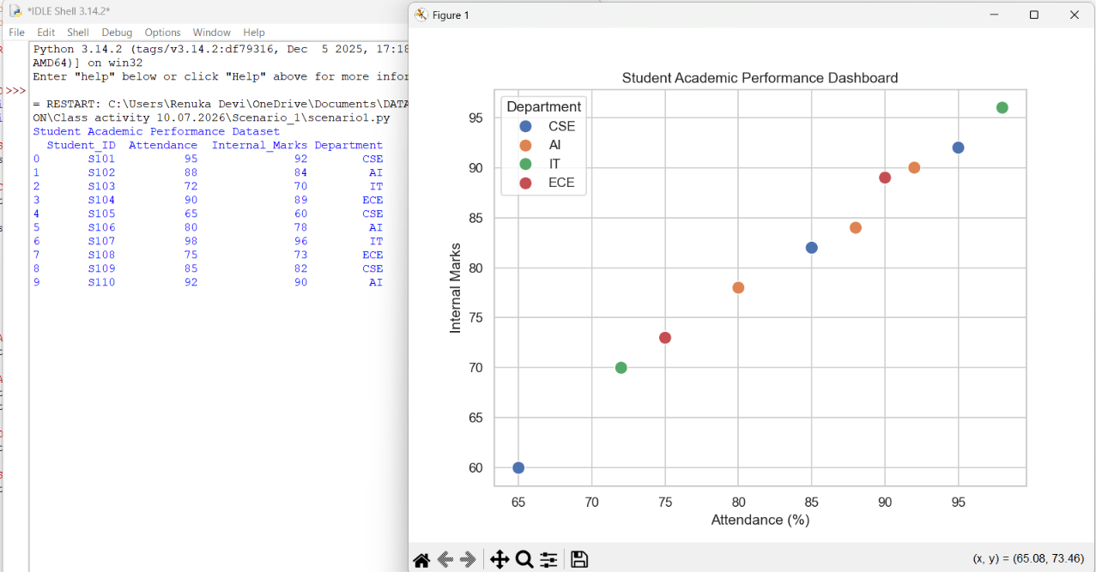
OUTPUT:

Scenario 2: Electric Vehicle Market Analysis
CODE:
import pandas as pd
import matplotlib.pyplot as plt

# Read the dataset
df = pd.read_csv("electric_vehicle.csv")

# Assign colors to manufacturers
colors = {
"Tata": "blue",
"MG": "green",
"BYD": "red",
"Mahindra": "orange",
"Hyundai": "purple",
"Tesla": "black",
"Kia": "brown",
"Volvo": "pink"
}

plt.figure(figsize=(10,6))

# Create Bubble Chart
for company in df["Manufacturer"].unique():
data = df[df["Manufacturer"] == company]

plt.scatter(
data["Battery_Capacity"],
data["Price"],
s=data["Driving_Range"],
color=colors[company],
alpha=0.6,
label=company
)

# Add labels for each vehicle
for i in range(len(df)):
plt.text(
df["Battery_Capacity"][i],
df["Price"][i],
df["Vehicle_Model"][i],
fontsize=8,
ha="left"
)

# Title and labels
plt.title("Electric Vehicle Market Analysis")
plt.xlabel("Battery Capacity (kWh)")
plt.ylabel("Price (₹)")
plt.legend(title="Manufacturer")
plt.grid(True)

plt.show()

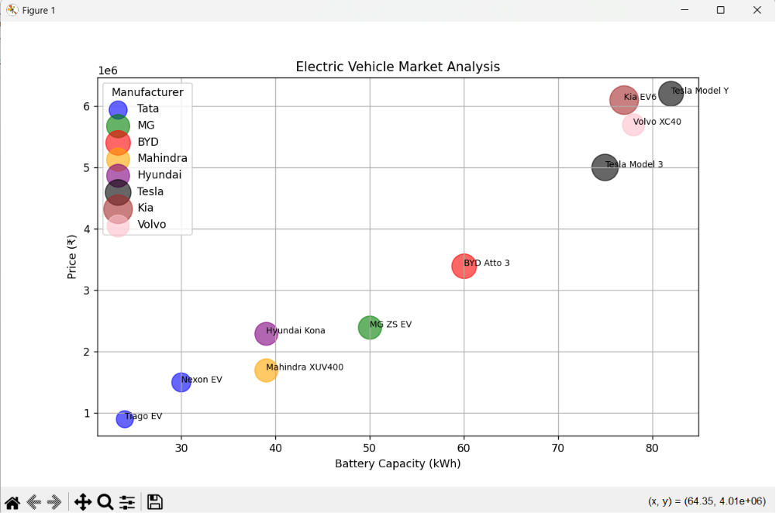
OUTPUT:

Scenario 3: Hospital Patient Admission Analysis
CODE:
import pandas as pd
import matplotlib.pyplot as plt

# Read the CSV file
df = pd.read_csv("hospital_patient_admission.csv")

# Display the dataset
print(df)

# Colors for each department
colors = ["blue", "green", "orange", "purple", "red", "cyan"]

# Create bar chart
plt.figure(figsize=(10,6))

bars = plt.bar(
df["Department"],
df["Number_of_Patients"],
color=colors
)

# Display treatment cost as labels on each bar
for bar, cost in zip(bars, df["Average_Treatment_Cost"]):
plt.text(
bar.get_x() + bar.get_width()/2,
bar.get_height() + 2,
f"₹{cost}",
ha='center',
fontsize=10,
fontweight='bold'
)

# Title and labels
plt.title("Hospital Patient Admission Analysis",fontsize=16, pad=20)
plt.xlabel("Department")
plt.ylabel("Number of Patients")

# Rotate x-axis labels for better readability
plt.xticks(rotation=15)

# Grid
plt.grid(axis='y', linestyle='--', alpha=0.5)

# Show graph
plt.show()
plt.tight_layout()
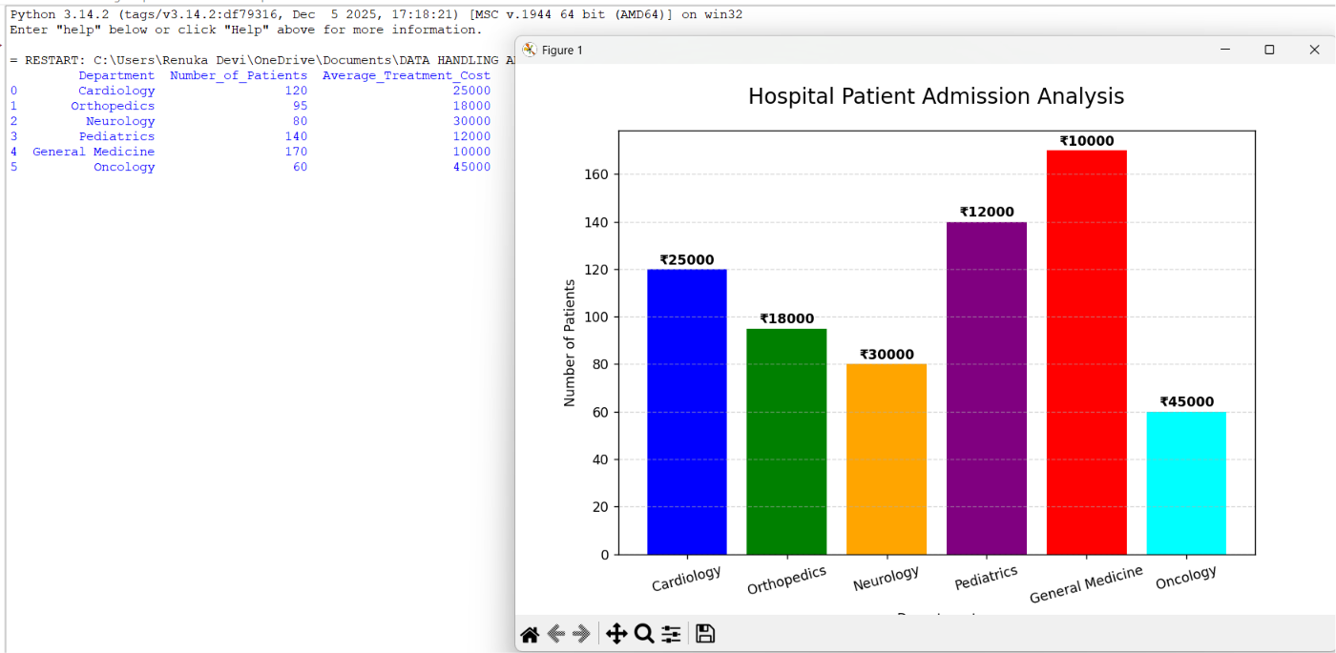
OUTPUT:

Scenario 4: Weather Monitoring System
CODE:
import pandas as pd
import matplotlib.pyplot as plt

# Read the dataset
df = pd.read_csv("weather_monitoring.csv")

# Display dataset
print(df)

# Create figure
plt.figure(figsize=(10,6))

# City-wise line styles and colors
styles = {
"Chennai": ("blue", "-"),
"Bangalore": ("green", "--"),
"Delhi": ("red", ":")
}

# Draw line for each city
for city in df["City"].unique():
city_data = df[df["City"] == city]

plt.plot(
city_data["Date"],
city_data["Temperature"],
color=styles[city][0],
linestyle=styles[city][1],
marker="o",
linewidth=2,
label=city
)

# Title and labels
plt.title("Weather Monitoring System", fontsize=16, pad=20)
plt.xlabel("Date")
plt.ylabel("Temperature (°C)")

# Legend
plt.legend(title="City")

# Grid
plt.grid(True, linestyle="--", alpha=0.5)

# Adjust layout
plt.tight_layout()

# Show graph
plt.show()
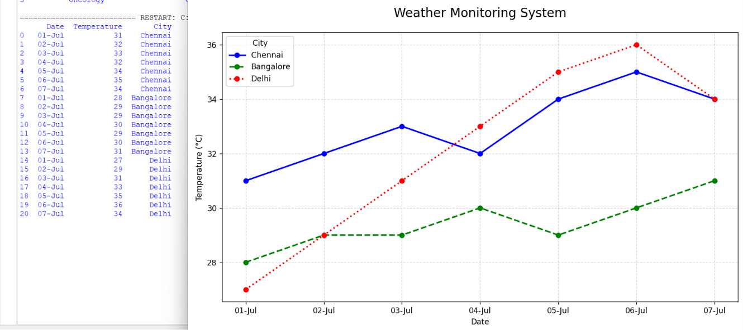
OUTPUT:
Scenario 5: Supermarket Sales Analysis
CODE:
import pandas as pd
import matplotlib.pyplot as plt

# Read dataset
df = pd.read_csv("supermarket_sales.csv")

print(df)

# Pivot data for grouped bar chart
pivot = df.pivot(index="Product_Category",
columns="Branch",
values="Sales_Amount")

# Plot grouped bar chart
pivot.plot(kind="bar", figsize=(10,6))

plt.title("Supermarket Sales Analysis", fontsize=16, pad=20)
plt.xlabel("Product Category")
plt.ylabel("Sales Amount (₹)")
plt.legend(title="Branch")
plt.grid(axis="y", linestyle="--", alpha=0.5)

plt.tight_layout()
plt.show()
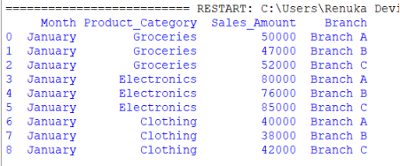
OUTPUT:

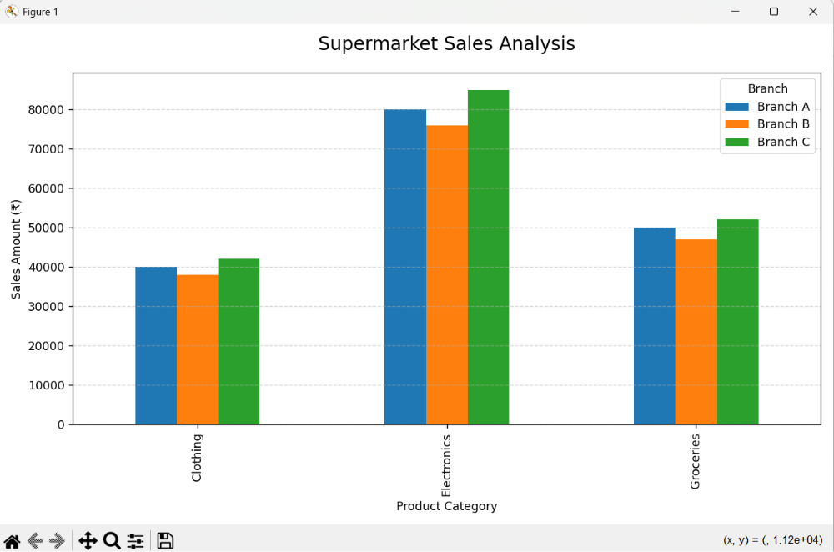
Scenario 6: Employee Salary Distribution
CODE:
import pandas as pd
import matplotlib.pyplot as plt

# Read the dataset
df = pd.read_csv("employee_salary.csv")

# Display dataset
print(df)

# Create Histogram
plt.figure(figsize=(10,6))

plt.hist(
df["Salary"],
bins=8, # Try changing to 5, 10, or 12
color="skyblue",
edgecolor="black"
)

# Title and labels
plt.title("Employee Salary Distribution", fontsize=16, pad=20)
plt.xlabel("Salary (₹)")
plt.ylabel("Number of Employees")

# Grid
plt.grid(axis='y', linestyle='--', alpha=0.5)

plt.tight_layout()
plt.show()
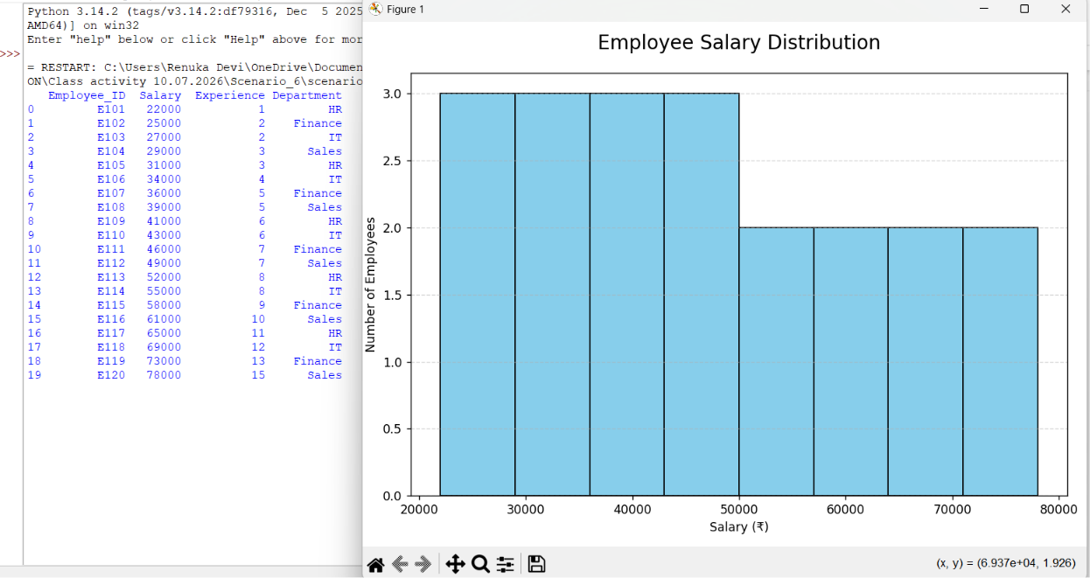
OUTPUT:
Scenario 7: Smartphone Market Comparison
CODE:
import pandas as pd
import matplotlib.pyplot as plt

df = pd.read_csv("smartphone_market.csv")

markers = {
"Samsung":"o",
"Apple":"s",
"OnePlus":"^",
"Xiaomi":"D",
"Realme":"*"
}

plt.figure(figsize=(10,6))

for brand in df["Brand"].unique():
data = df[df["Brand"] == brand]

plt.scatter(
data["RAM"],
data["Price"],
s=data["Storage"],
c=data["Processor_Speed"],
cmap="viridis",
marker=markers[brand],
alpha=0.8,
label=brand
)

plt.colorbar(label="Processor Speed (GHz)")
plt.title("Smartphone Market Comparison", fontsize=16, pad=20)
plt.xlabel("RAM (GB)")
plt.ylabel("Price (₹)")
plt.legend(title="Brand")
plt.grid(True)
plt.tight_layout()
plt.show()
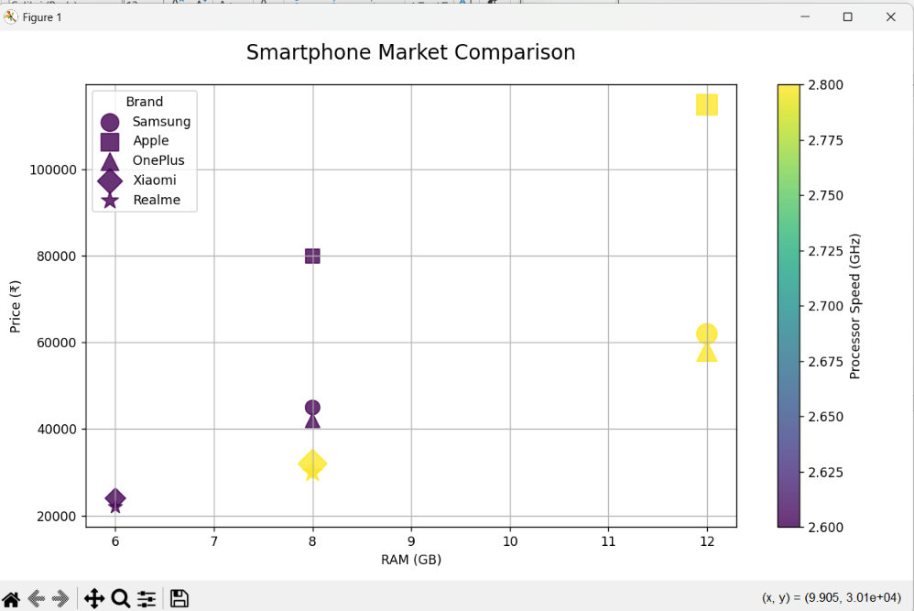
OUTPUT:

Scenario 8: Online Movie Rating Analysis
CODE:
import pandas as pd
import matplotlib.pyplot as plt
import seaborn as sns
# Read dataset
df = pd.read_csv("movie_rating.csv")
# Create pivot table
heatmap_data = df.pivot(
index="Release_Year",
columns="Genre",
values="Average_Rating"
)
# Plot heatmap
plt.figure(figsize=(8,5))
sns.heatmap(
heatmap_data,
annot=True,
cmap="YlOrRd",
linewidths=0.5,
fmt=".1f"
)
plt.title("Online Movie Rating Analysis", fontsize=16, pad=20)
plt.xlabel("Genre")
plt.ylabel("Release Year")
plt.tight_layout()
plt.show()
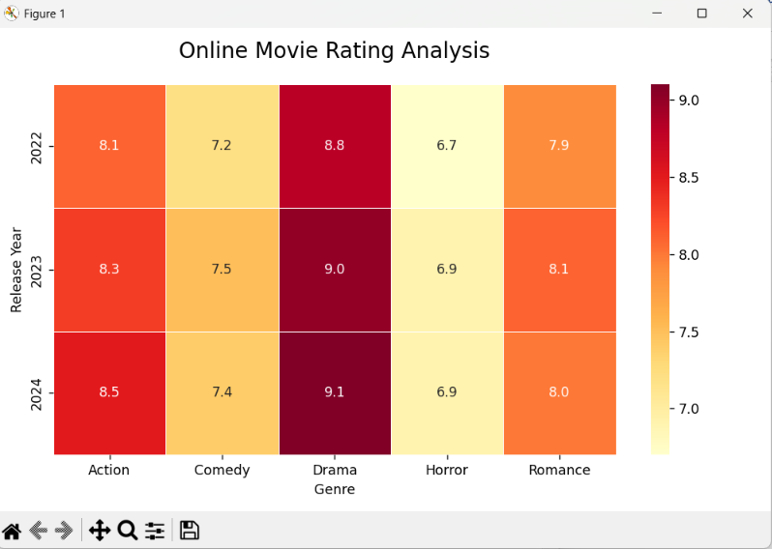
OUTPUT:
Scenario 9: COVID-19 State-wise Analysis
CODE:
import pandas as pd
import matplotlib.pyplot as plt

# Read dataset
df = pd.read_csv("covid_state.csv")

# Sort states by active cases
df = df.sort_values(by="Active_Cases", ascending=False)

plt.figure(figsize=(10,6))

bars = plt.bar(
df["State"],
df["Active_Cases"],
color=plt.cm.Reds(df["Active_Cases"] / df["Active_Cases"].max())
)

# Add value labels
for bar in bars:
plt.text(
bar.get_x() + bar.get_width()/2,
bar.get_height() + 100,
str(int(bar.get_height())),
ha='center',
fontsize=9
)

plt.title("COVID-19 State-wise Active Cases", fontsize=16, pad=20)
plt.xlabel("State")
plt.ylabel("Active Cases")
plt.xticks(rotation=30)
plt.grid(axis="y", linestyle="--", alpha=0.5)

plt.tight_layout()
plt.show()
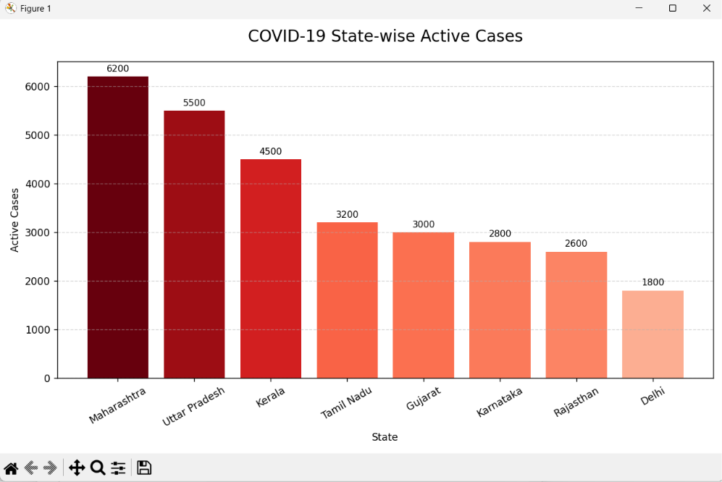
OUTPUT:

Scenario 10: Iris Flower Classification
CODE:
import pandas as pd
import matplotlib.pyplot as plt
# Read dataset
df = pd.read_csv("iris_dataset.csv")
# Colors for each species
colors = {
"setosa": "red",
"versicolor": "green",
"virginica": "blue"
}
# Shapes for each species
markers = {
"setosa": "o",
"versicolor": "s",
"virginica": "^"
}
plt.figure(figsize=(10,6))
for species in df["Species"].unique():
data = df[df["Species"] == species]
plt.scatter(
data["Sepal_Length"],
data["Petal_Length"],
s=data["Sepal_Width"] * 80, # Point size
color=colors[species], # Color = Species
marker=markers[species], # Shape = Species
edgecolors="black",
label=species
)
plt.title("Iris Flower Classification", fontsize=16, pad=20)
plt.xlabel("Sepal Length (cm)")
plt.ylabel("Petal Length (cm)")
plt.legend(title="Species")
plt.grid(True)
plt.tight_layout()
plt.show()
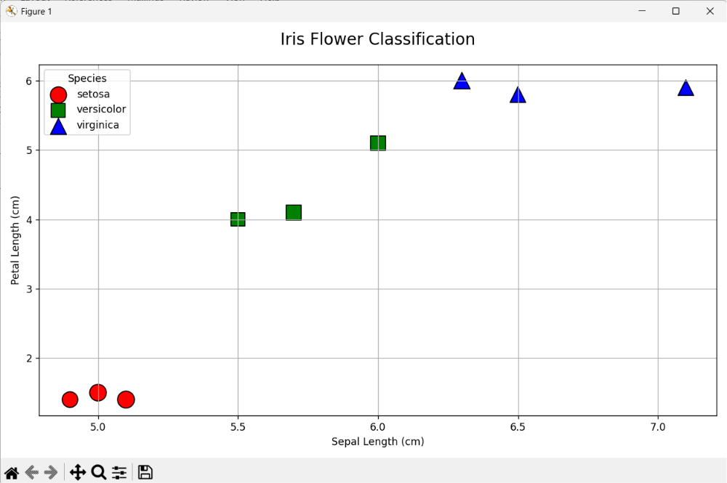
OUTPUT:

